**Semester 1 2019** [**BAFI 3192**](https://rmit.instructure.com/courses/46151) **- RISK MANAGEMENT**

**ASSIGNMENT 3**



Tran Hoang Long s3635014

Lecturer: Nguyen Thanh Binh

**Table of Content**

**Trading philosophy** **4**

**II. The overall market and macroeconomics condition** **5**

**III. Portfolio Construction** **8**

STOCK ANALYSIS 10

Amazon 10

Fundamental Analysis 10

B. Technical Analysis 10

C. News 11

2. Apple Inc 11

Fundamental Analysis 11

B. Technical Analysis 11

C. News 12

3. Abbott Laboratories 12

Fundamental Analysis 12

Technical Analysis 13

C. News 13

4. Netflix 13

Fundamental Analysis 13

Technical Analysis 14

C. News 14

5.Tesla 14

Fundamental Analysis 14

Technical Analysis 15

6. Carrizo Oil & Gas 15

Fundamental Analysis 15

Technical Analysis 16

7. Qualcomm 16

Fundamental Analysis 16

Technical Analysis 17

C. News 17

8.Booking Holdings 18

Fundamental Analysis 18

Technical Analysis 18

9. VMWare 19

Fundamental Analysis 19

Technical Analysis 19

10. Intuitive Surgical 20

Fundamental Analysis 20

Technical Analysis 20

C. News 20

11. Graham Holdings Company 21

Fundamental Analysis 21

Technical Analysis 21

B. Expected Market Return on Portfolio 22

**IV. Risk identification** **24**

Systematic Risk of portfolio ( Beta) 24

2. Unsystematic Risk 25

**V. Hedging** **26**

1. Options Contract 26

**VI. Trading Diary** **27**

**VII. Reflection** **29**

Comparison of the return expected & the actual return achieved 29

2. An analysis of your own risk appetite 29

3. Reflection 29

**References** **30**

**Appendix** **32**

# **Trading philosophy**

The ultimate goal of this investing process is to make as much profit as possible within two weeks as well as to practice stock investing and apply risk management process into real life situation. In this investment game, every data available is real time updated from the US stock markets such as New York Stock Exchange and NASDAQ with stocks from the Down Jones, SP500 index and other minor ones. Therefore, not only fundamental and technical analysis are required to choose which stocks to trade but also macroeconomics situations. However, Technical Analysis with Growth Investing are mainly used as trading philosophies to make profit in short duration.

On the first hand, stocks fundamental analysis focuses on the company Price to Earnings ratio, Earning per Share and Debt / Equity ratio to find the stock’s intrinsic value and determine whether the stock is worth its price ( Jean Folger, n.d). Other ratios such as Return on Equity are also examined in order to measure the company’s financial performance through its net return on its assets.

On the second hand, Technical analysis plays a major role in the stock’s buying and selling decision through its trend movement using historical data of stocks price and volume.

Last but not least, macroeconomics news such as political policy changes about international change or even scandals may cause short term fluctuations in stocks price. Therefore, these external factors are also considered to determine the volatility of the stocks. For example, a news about government encouragement of technology sector and tax reductions, or news of a technology firm successfully invented something may cause the price of that company, or companies within the technology sector may be increased due to the potential growth although they have yet any positive changes in fundamental analysis. Therefore, growth investors may financial capitalise from short term increase in price due to the positive news, but also having higher risks while value investors focuses on undervalued firms with low P/E ratio, but also less risks and more potential growth in long term.

Since technical analysis uses the historical data of stocks price and volume to identify market trends and surf stocks waves, which sometimes causes stocks overvalued traded while fundamental analysis concentrates on the company statistics for instinct value investing. Therefore, Technical analysis is more suitable for short term trade, which is ideal in this investment game while fundamental analysis is more suitable for long term investment. Also, Macroeconomics news also play a major role in buying and selling due to its urgent impact on stock prices to maximise profit or to cut loss.

# II. The overall market and macroeconomics condition

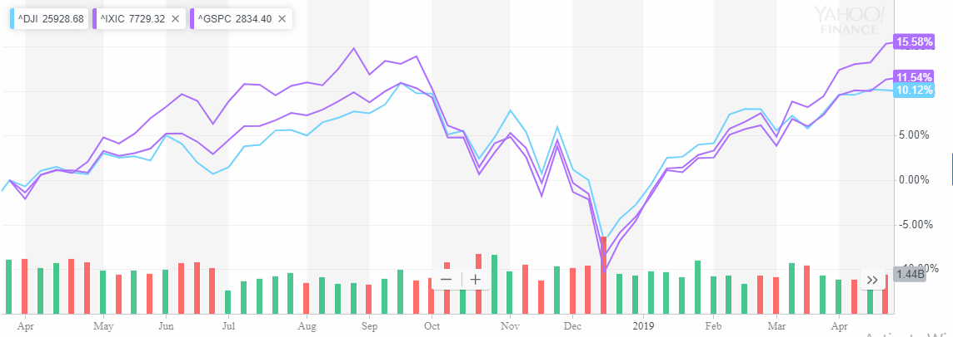

**Figure 1. SP 500, Down Jones & Nasdaq Index in 1 year . Image retrieved from Yahoo Finance, n.d**

It can be seen from the chart above that these three market indices that the US financial market has just recovered from a terrible falling in price in late December 2018. According to CNN Business, 2018, this year was the most extremely volatile year for US stocks market. However, this year was also the year that the three indices set all time record high. Although the year 2018 ended with this terrible drop, it is stated that investors would not mind because the drop is short term and mostly due to the trade war between US and China. Infact, thanks to the President Trump’s tax cut, US firms are doing very well although there are claims that the benefits are minimal ( Tim Madehy 2018) ( see Figure 1 Appendix). It is revealed that China also suffered from a worse declined in their stocks market comparing to the US. Shanghai Composite, Shenzhen Composite and Hong Kong Hang Seng experienced a following 25%, 33% and 14% drop (CNN Business 2018)(Appendix figure 2), which resulted in a compromise for an end of the trade war from Chinese President Xi Jinping, which later lead to a recovery in US Stocks market (Ana Swanson 2019).

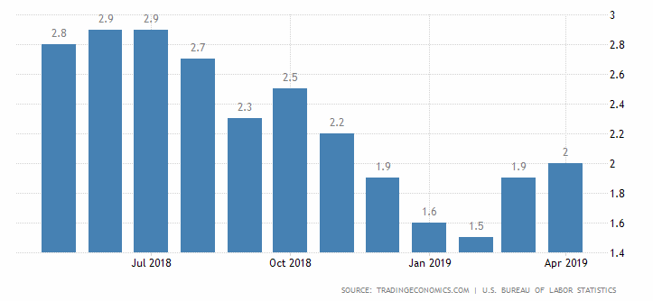

**Figure 2. US inflation rate. Image retrieved from TradingEconomics, n.d.**

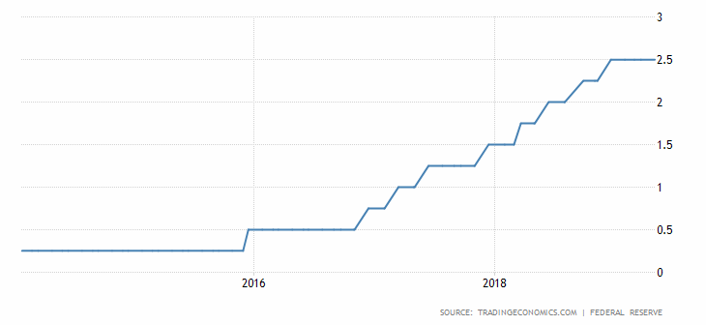

**Figure 3. US interest rate. Image retrieved from TradingEconomics, n.d**

Furthermore, US interest rate has been increasing while Inflation Rate is being stably kept at 2%. As a result, USD will be appreciated, which make import cheaper, which is good for the US economy in this situation because US is an import country and the majority of its blue chip companies have their products manufactured overseas. Also, because oil price is stabilizing after a period of increasing, it may decelerate the profit of the oil industry. However, for the economy in a whole, this is a good news because production cost are reduced, which means revenues are boosted.

From these reasons above, it is apparent that the US in general and US stock markets are expect to continue to have an upward trend in short term, which is good for our investing plan.

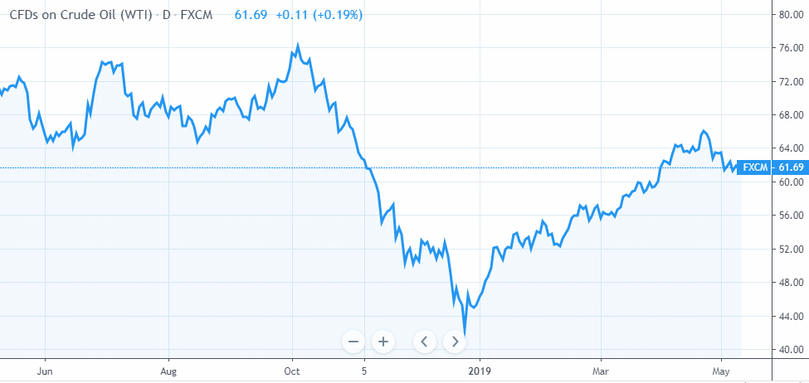

**.Figure 4. US Crude Oil price. Image Retrieved from TradingView, n.d.**

# III. Portfolio Construction

**Initial Portfolio**

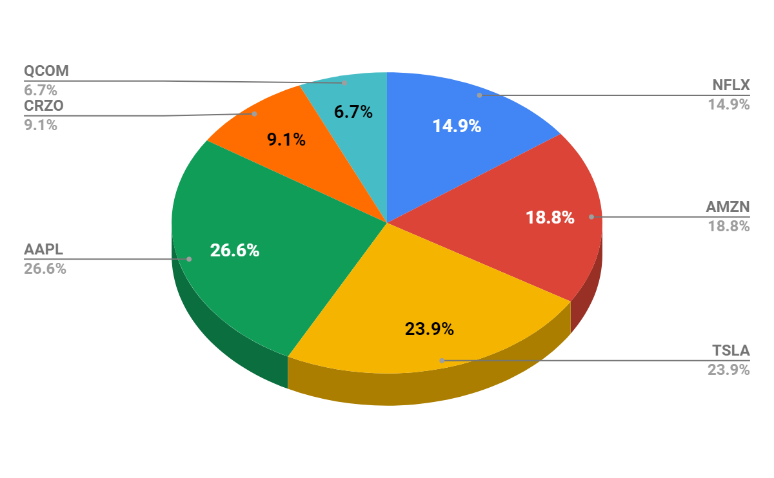

**Figure 5. Stocks Weights in initial Portfolio**

In the initial portfolio, I striked on mostly technology and blue chip companies such as Apple, Amazon and Tesla because not only these companies are doing well recently but also their stock prices is increasing. Because the goal of this trading section is to have a return as high as possible and I am a risk taker, I let a minimal portion of my portfolio for two companies having high beta but also having high return recently. They are Qualcomm and Carrizo Oil & Gas, Inc, with a total percentage of 15.8 respectively.

**Adjusted Portfolio**

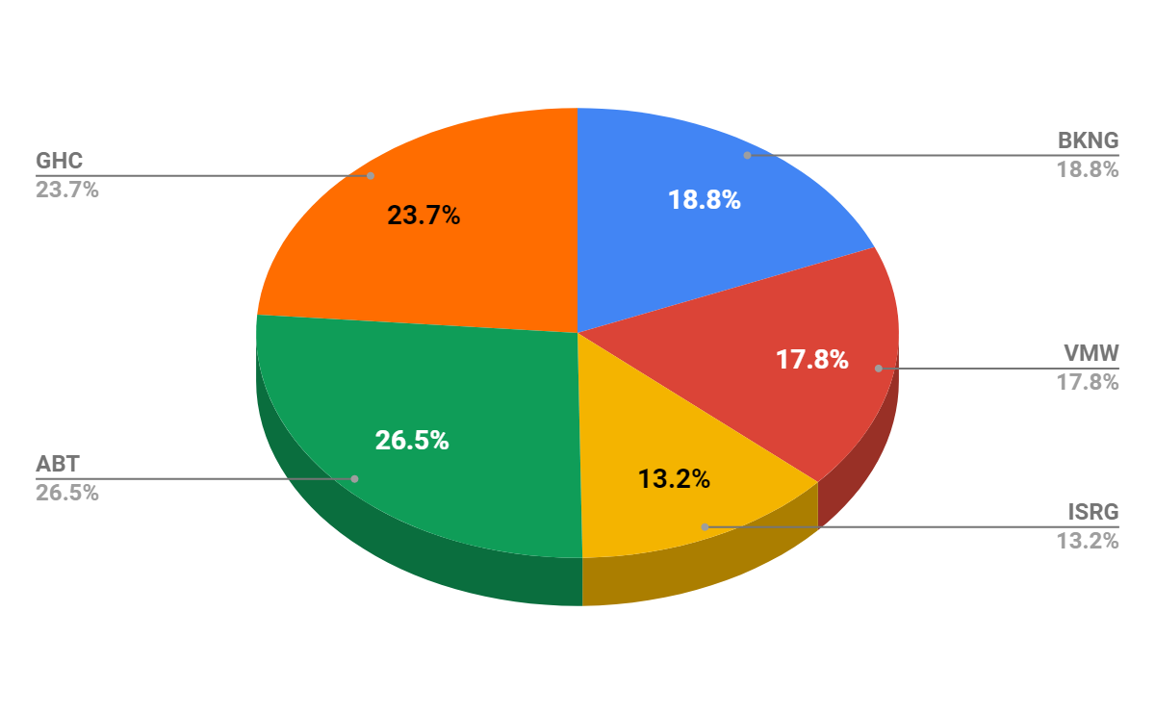

**Figure 6. Stock weights in adjusted portfolio**

On the next two days, because there are fluctuations in the majority of stock prices in the initial portfolio and it is too risky to keep holding them until the section is over, I decided to sell all of them, finalise my profit and make a new portfolio. In this newly adjusted portfolio, stocks with less volatility, which means lower beta is more favored. They are Booking Holdings, VMWare Inc, Graham holdings and Abbot which beta varies from 0.65 to 1.1. However, similarly to the initial portfolio, a small portion is kept for stocks with recently increasing return to surf its wave to maximise profit, which is Intuitive Surgical Inc.

## **STOCK ANALYSIS**

### **Amazon**

#### **Fundamental Analysis**

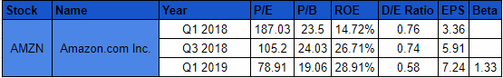

**Table 1. Amazon’s Fundamental Analysis. Data adapted from CSIMarket, n.d.**

It can be seen that Amazon is having a falling P/E ratio while its EPS and ROE is increasing throughout quarters. Its Debt/Equity ratio is also falling. Hence, it is apparent that the stock could be undervalued, which is an opportunity to buy. Although it has a relatively high beta of 1.33, it could bring a high return in this situation.

#### **B. Technical Analysis**

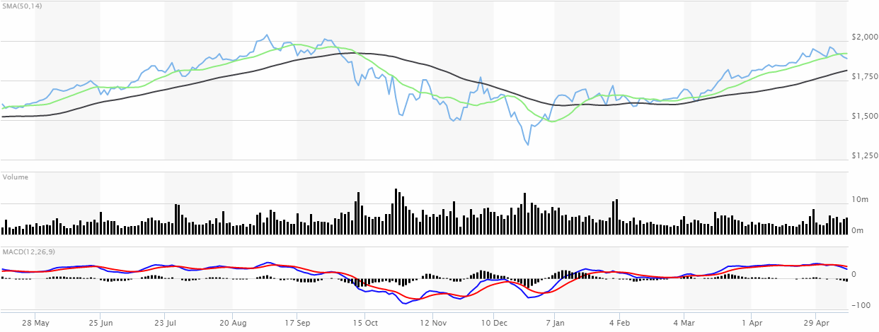

**Figure 7. Amazon’s technical analysis. Image retrieved from Marketwatch, n.d.**

A glance at the technical analysis reveals that Amazon stock price is experiencing an upward trend. Therefore it is profitable to buy this. It is also rated as a should buy stock on MarketWatch Analyst Ratings

#### **C. News**

According to Amazon’s announcement on its website, the annual meeting will take place in 22nd of May. During this period, there is a buying signal to financially capitalise from the annual meeting, in which the SMA14 is now way more above the SMA50

### **2. Apple Inc**

#### **Fundamental Analysis**

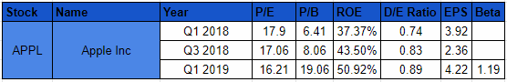

**Table 2. Apple Fundamental Analysis. Data adapted from CSIMarket, n.d.**

It can be seen that Apple recently has witnessed a fluctuation in their business performance with hates and likes about their latest iPhone products and comparisons to Samsung or Huawei. However, because the company is still having an increasingly positive ROE and EPS. It is still worth it to invest in in a long run along with its acceptable beta of 1.19. A falling P/E ratio trend while its ROE and EPS also means that AAPL is still being undervalued.

#### **B. Technical Analysis**

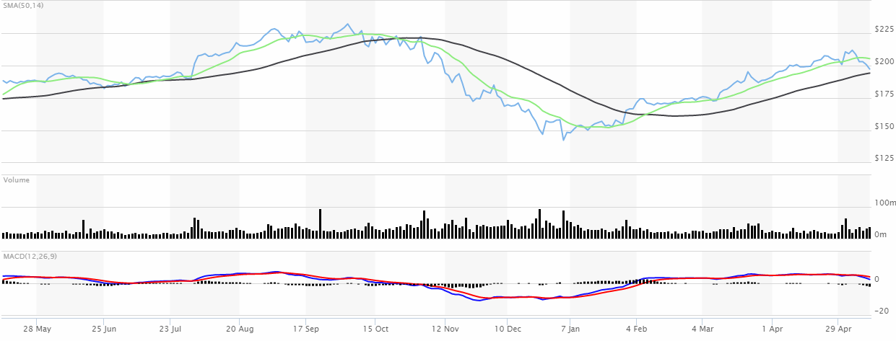

**Figure 8. Apple’s Technical Analysis. Image retrieved from Marketwatch, n.d.**

Historical data of APPL price reveals that although its price recently has decreased, it is still having an upward trend and the fall of the price still not penetrated the resistance level, which is the simple moving average. Marketwatch has rated the stock as an overtrading stock, which could be the reason leading to its price fluctuations.

#### **C. News**

According to Bob Bryan, 2019, the main reason implements a negative results in Apple performance is the US - China trade deal with US’s tariff on goods imported from China and China’s tariff on US product. Being an American company having their products manufactured in China, Apple products bear not only import tariff from US but also increased tax on US products in China.

### **3. Abbott Laboratories**

#### **Fundamental Analysis**

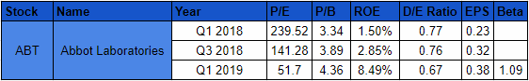

**Table 3. Abbot’s Fundamental Analysis. Data adapted from CSIMarket, n.d.**

It can be seen that Abbot’s P/E is being falling recently while it EPS and ROE is increasing, which means that this stocks is being traded undervalued. However, its P/B ratio is increasing while its D/E ratio is decreasing also illustrate that the stock is still potential to further rise. Also, having a 1.09 beta, which means the stocks performance would not differ much from the overall market performance, is ideal to be invested in in this scenario, when the entire Market is expecting an upward trend.

#### **Technical Analysis**

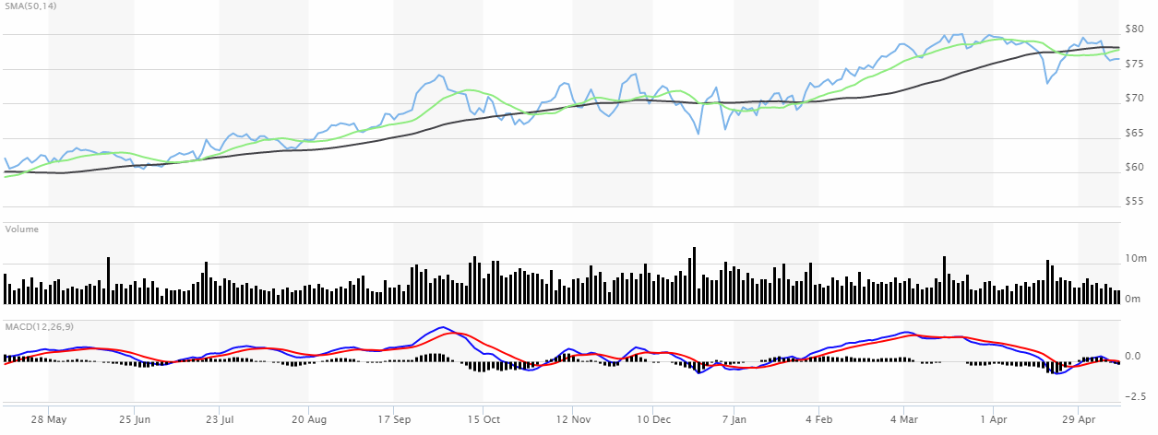

**Figure 9. ABT’s Technical Analysis. Image retrieved from Marketwatch, n.d.**

It can be seen from the technical analysis that ABT is smoothly increasing over time although there are fluctuations in price. However, the ups and downs are not too wild, which means there is an opportunity to buy low and later sell high.

#### **C. News**

According to Reuters 2019, Abot just had a higher than expected sales in Q1 2019, which means that company is doing well and it is ideal to invest in ABT stock.

### **4. Netflix**

#### **Fundamental Analysis**

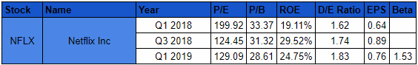

T**able 4. Netflix Fundamental Analysis. Data adapted from CSIMarket, n.d.**

At first, because Netflix is having a relatively high beta of 1.53 while their business seems not quite positive recently, which results from the downtrend fluctuations in their ROE, EPS and even in their D/E ratio. However, because these ratios seems to be recovered after failing, it could be an opportunity to surf the wave.

#### **Technical Analysis**

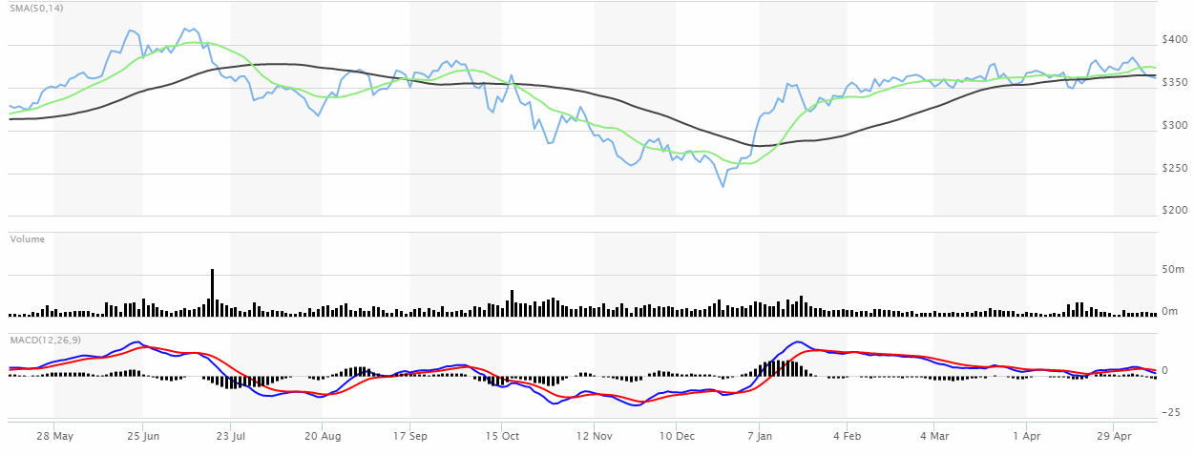

**Figure 10. NFLX’s technical analysis. Image retrieved from Marketwatch,n.d.**

As we can see from the technical analysis, the stocks is fluctuating daily. However, because the price still not penetrates the resistant level, which is the SMA(50) and even SMA(14). We could surf these waves.

#### **C. News**

According to Rodriguez, 2019, Netflix just had a not as good as expected Q1 performance. This could be the reasons leads to its decrease in prices. However, because the stock is currently overtrading ( Marketwatch, n.d). We can buy low and then sell higher to make quick profit

### **5.Tesla**

#### **Fundamental Analysis**

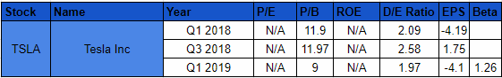

**Table 5. Tesla Fundamental Analysis. Data adapted from CSIMarket, n.d**.

Tesla is a special company by having a deficit in their profit, which results in their N/A in P/E and ROE. However, The firms are still in developing stage, which means there is still potential growth in future.

#### **Technical Analysis**

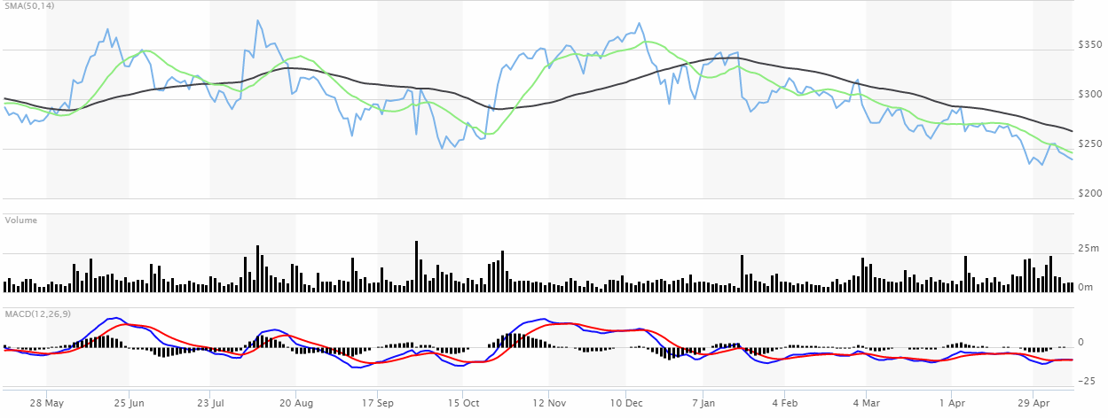

**Figure 11. Tesla Technical Analysis. Image retrieved from Marketwatch, n.d.**

Although its historical price reveals a downtrend, sometimes it also means an opportunity to buy because there are also ups and downs, not just a stable downward trend. As a results, I decided to take the risk to surf the wave.

### **6. Carrizo Oil & Gas**

#### **Fundamental Analysis**

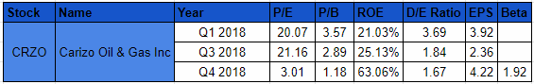

**Table 6. CRZO fundamental analysis. Data adapted from CSIMarket, n.d.**

Carrizo Oil & Gas just has decent ratios in their Fundamental Analysis. Having their ROE nearly tripled and EPS nearly doubled in within 6 months while their P/E and P/B decreasing, it is apparent that the stocks is being traded undervalued. Therefore, it would likely to continue increasing. Although it has a very high beta of 1.92, I still spare a small portion of 9.1% in my portfolio for this stock.

#### **Technical Analysis**

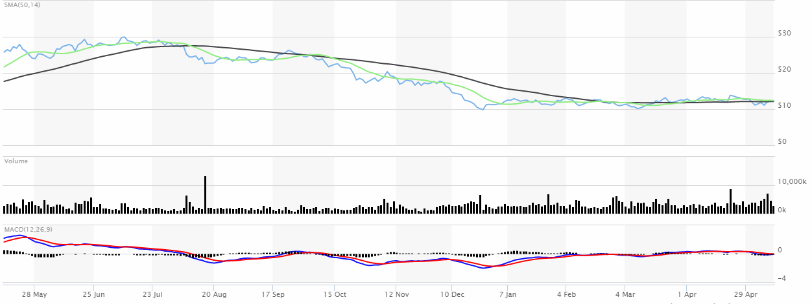

**Figure 12. CRZO Technical Analysis. Image retrieved from Marketwatch, n.d.**

The technical data analysis reveals that the stock price recently has become quite stable, the current price trend, SMA50 and SMA14 are nearly the same. Therefore, it is ideal to buy.

### **7. Qualcomm**

#### **Fundamental Analysis**

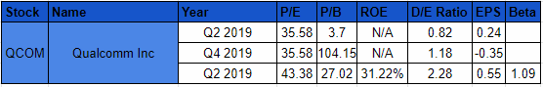

Table 7. QCOM Fundamental Analysis. Data adapted from CSIMarket, n.d.

It can be seen that QCOM is being overvalued due to the difference in its D/E ratio, which is doubled within 6 months while its increasing rate in P/E and EPS is not that fast. However, overvalued means more growth potential in short term, which is ideal since the trading section only last 14 days. A relatively low beta of 1.09 means this overvalued is more tolerant to investors.

#### **Technical Analysis**

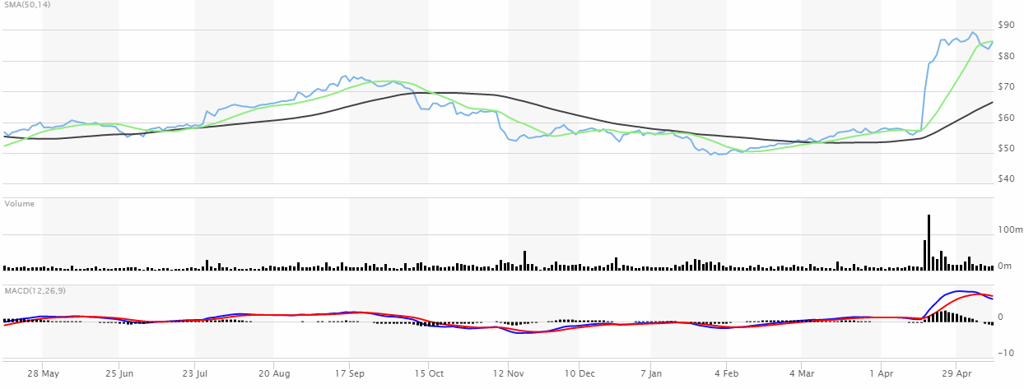

**Figure 13. QCOM Technical Analysis. Image retrieved from Marketwatch, n.d.**

From the historical data of QCOM, its price has been surging fast recently, which is an opportunity to make profit. Also, there is an apparent buying signal, which is the SMA14 now is above SMA50.

#### **C. News**

According to Luke Lango 2019, Qualcomm stock could skyrocket after the lawsuit case of Apple paying many billions USD of royalty to Qualcomm is settled. Therefore, there is an opportunity to make big money.

### **8.Booking Holdings**

#### **Fundamental Analysis**

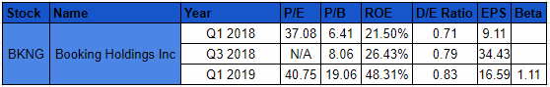

Table 8. BKNG fundamental analysis. Data adapted from CSIMarket,n.d.

It can be seen that Booking Holdings is potential for a stable growth in price, which results from its stable increasing in ROE. Although its D/E slightly increased from 0.79 to 0.83, its beta of just 1.11 make it tolerated.

#### **Technical Analysis**

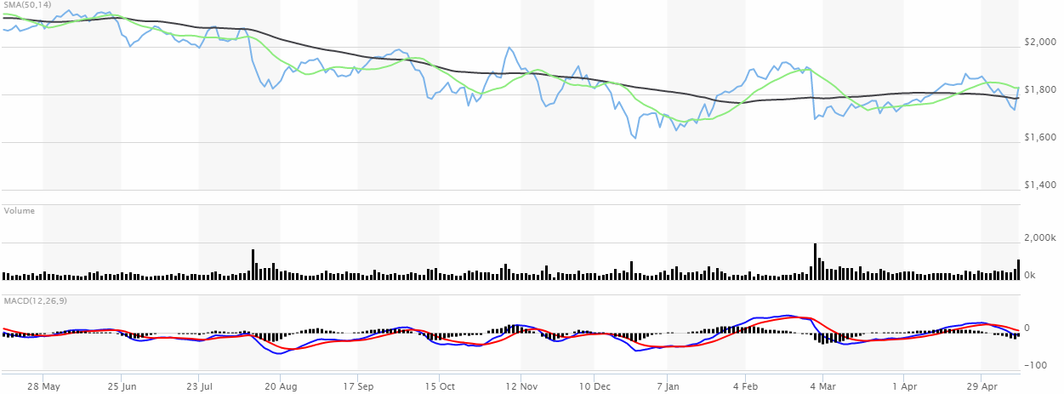

**Figure 14. BKNG Technical Analysis. Image retrieved from Marketwatch, n.d.**

According to the technical analysis, although BKNG is experienced a downward trend in price, there are repeatedly periods of ups and downs in its trends. Since it just ended a falling period in early April and started increasing again. It is ideal to buy and surf the wave.

### **9. VMWare**

#### **Fundamental Analysis**

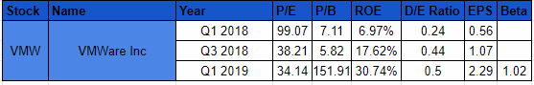

**Table 9. VMWare fundamental analysis. Data adapted from CSIMarket, n.d.**

Although P/B ratio is quite high, its just in short term. The others ratios such as P/E is decreased while its ROE and EPS is increasing stably, which means that this company is doing well. It also has a very attractive beta of 1.02, which means it less volatile. Since the overall market index is going upward, it is apparent this company will face the same trend.

#### **Technical Analysis**

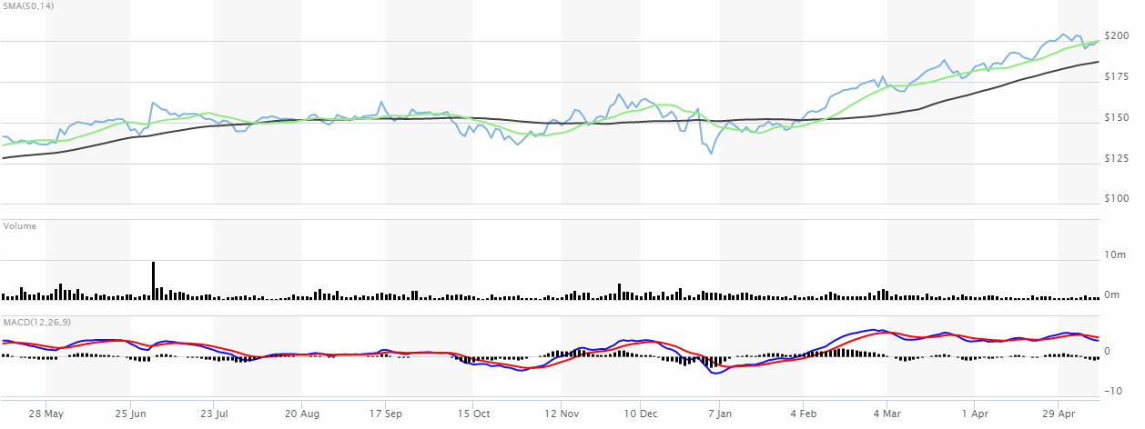

**Figure 15. VMW technical analysis. Image retrieved from Marketwatch, n.d.**

The technical analysis reveals that the stock price is stably increasing. Therefore, it is an opportunity for a safe increase in return.

### **10. Intuitive Surgical**

#### **Fundamental Analysis**

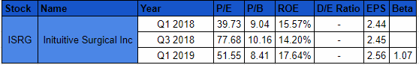

Table 10. ISRG Fundamental analysis. Data adapted from CSIMarket, n.d.

The special advantage of this company is that they operate by their own capital, which results in no debts at all. Another plus is its stable EPS and ROE while P/E Ratio is decreasing, which means it is being trade undervalued.

#### **Technical Analysis**

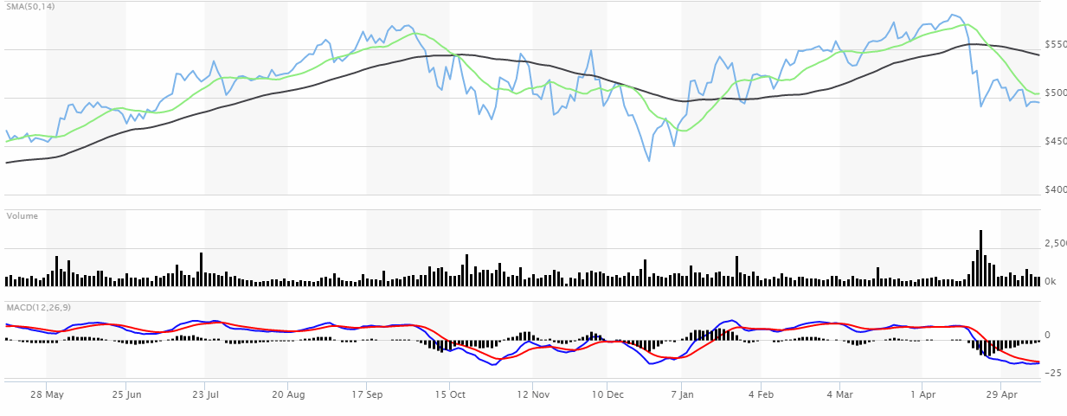

**Figure 16. ISRG technical analysis. Image retrieved from Marketwatch, n.d.**

Technical analysis reveals that it has just suffered from a huge drop in price. Therefore, there is an opportunity to buy the stock at the correct price before it is going to surge again. This is definitely a safe investment for short term.

#### **C. News**

Although there is a drop in price, it is a correction from the market for the previous overvalued price after the company announced their Q1 report. According to Emerson, 2019, ISRG will continue to rise because it got FDA approvals on several procedures, which facilitate its business.

### **11. Graham Holdings Company**

#### **Fundamental Analysis**

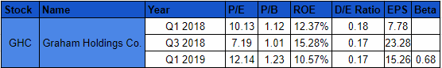

**Table 11. GHC Fundamental analysis. Data adapted from CSIMarket, n.d.**

The fundamental analysis above reveals that the stocks is deal to invest in for value investors with a P/B ratio nearly 1. Also, it has a relatively low P/E comparing to other blue chips companies. Its beta is also magnificent, which is just 0.68, even less volatile than the overall market.

#### **Technical Analysis**

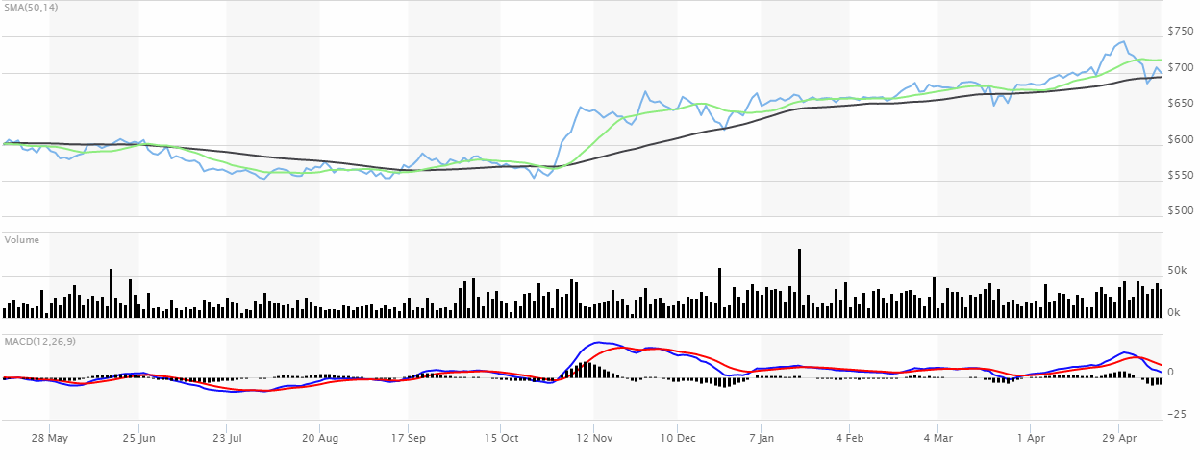

**Figure 17. GHC Technical Analysis. Image retrieved from Marketwatch, n.d.**

It is apparent that there is a buy signal in this stock because of its upward trend and SMA14 being above SMA50. I would use value investing approach for Graham Holdings.

## **B. Expected Market Return on Portfolio**

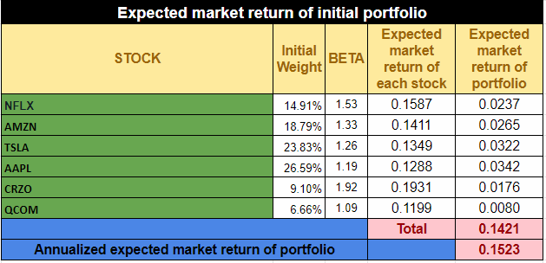

**Table 12. Annualized Expected Return**

The risk free rate is the rate of the US T bill because there is almost no risk that the US government would be default on that bill. According to US Department of the Treasury, 2019, the current rate of the T Bill is 2.38% per annum on 10th of May. Also, using Online SP500 Annualized Return Calculator, the current annual market return of the SP 500 is 10.12%.

To calculate expected return of the initial portfolio, firstly I calculate each expected market return of them in general using the formula

Expected return E(R) = + Portfolio's Beta( - )

Then I calculate the weight of each stocks in my portfolio. And then multiply the Expected return with the weights, I have the expected return of each stocks in my portfolio.

Lastly, I calculate the annualised expected market return using the expected market return of portfolio. Since the trading section ends in two weeks = 26 periods per annum. We have the equation :

Annualized expected market return of portfolio = 15.23%

However, because 2 days later I was uncertain about my portfolio due to there are changes in the market. Therefore I adjusted my initial portfolio into a completely new one.

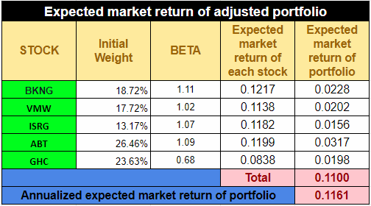

**Table 13. Annualized expected market return**

Similarly to the procedures above, we have our Annualized expected market return as 11.61% for this portfolio.

# IV. Risk identification

There are two main kinds of risk, systematic risk and unsystematic risk.

#### **Systematic Risk of portfolio ( Beta)**

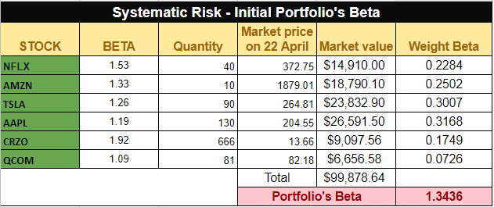

**Table 14. Portfolio Beta**

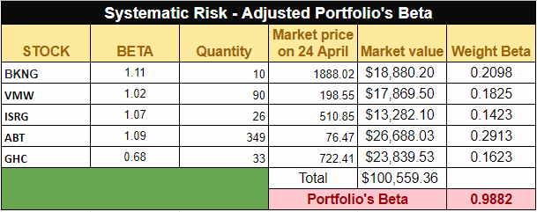

**Table 15. Adjust Portfolio’s Beta**

Systematic risk the volatility of the market, which can not be voided by portfolio diversification. Systematic risks are major macroeconomics factors that can affect the entire market such as recessions and wars. ( Amy Fontinelle 2018). On the other hand, Beta is a measurement of the volatility of an individual stock in the stock market comparing to the entire market. A beta less than 1 means that the stock is less volatile than the overall market while a beta more than 1 means reversely. (Willy Kenton 2019).

To calculate the Portfolio’s Beta, we use the formula :

= *

As a result, I have the beta of my initial portfolio as 1.3436 and the beta of the adjusted portfolio as 0.9882, which means that the initial portfolio is 34,36% more volatile than the overall market while the final one is 2,18% less volatile than the overall market. Therefore my final portfolio is a little less sensitive to systematic risk than the entire stock market.

#### 2. **Unsystematic Risk**

Unsystematic Risks are risks that are specific for a company or an industry and can be voided through portfolio diversification. (James Chen 2017). Therefore, to void the unsystematic risk, we should diversify our portfolio into multiple sectors and companies, not putting all eggs into one basket.

# V. Hedging

## 1. **Options Contract**

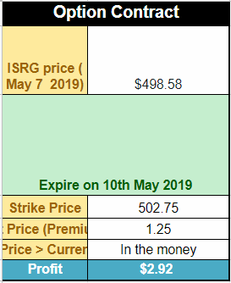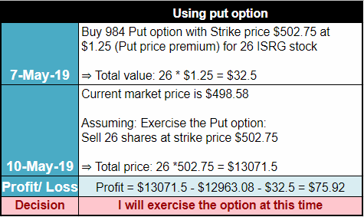

**Table 15+16. Option contract**

Since ISRG has been fluctuating recently, I would like to hedge it against potential losses with an option contract

Since the cost of the Premium is not large but it can prevent the drop of price. I will exercise the option.

# VI. Trading Diary

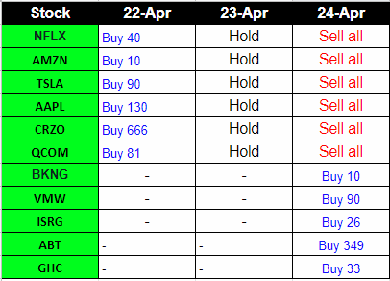

**Table 12. Trading Diary**

On the first day trading, I bought the amount of stocks on the table above. They were making huge profit on the day after, increasing the portfolio gain to 1.42% on 23 of April, which is also the reason why i decided to hold them.

On 24th of April, because Carrizo Oil and Gas and Tesla started to drop while other stocks started wildly fluctuate in a downward trend as well as the gain of the portfolio decreased. I decided to sell them all to close my profit and to make another portfolio less volatile. The new portfolio are the six new stocks above.

Since then, the gain started increasing stably, from 0.51% on 24 April to 1.54% on 25 April and continued to increase to its peak on 30/4 at 2.45% gain. I could have sold them all to close my profit but i decided to go with the flow until the trading session is over. I created this portfolio also for a passive investing purpose, not just proactive investing.

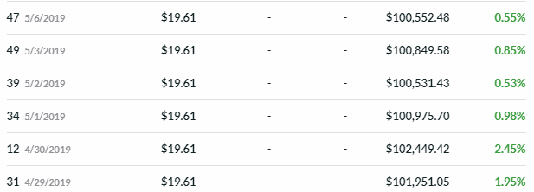

**Table 13. Portfolio Gain.**

However, I did not check my portfolio in the next days because it was Vietnamese National holiday. I continued holding these stocks until I checked it on 6th of May. This time the overall portfolio gain was just only 0.55%. Because it happened not only me but also to the majority of other students, I did not adjust my portfolio thinking that the market will stabilize itself in the next day.

Unfortunately, on 5/7, the consequence of President Trump’s claim China for delaying to finalize the Trade Talk with threats about imposing more tariff on the rest of Chinese Goods put the entire Market on chaos ( Nasdaq Stock Market News 2019). Putting my portfolio on a -2.35% loss. Because it was definitely a loss if I decided to sell all the stocks, I decided to continue holding them until the market adjust again.

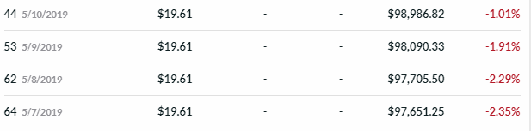

**Table 14. Portfolio Gain on last 4 days**

And the market did adjust to its positive trend on the next days and the market indexes started going up again. It can be seen that this falling in price is due to the systematic risk.

To sum up, i made 17 transactions in 14 days.

# **VII. Reflection**

#### **Comparison of the return expected & the actual return achieved**

**Expected return** = Deposit* ( 2-week expected market return of portfolio +1 ) = 100000* (1 + 0.1161/26) = $100,446.54

**Actual return** = $98,986.82

In 2 weeks, our portfolio is expected to be $100,446.54 from the initial value of $100,000. However, the Actual return is only $98,986.82, which is a negative rate. Hence, the market performance is weaker than the expectation. However, this unexpected return is due to the systematic risk from the US-China Trade war. Therefore, only stocks with beta even below 1 can stand.

#### **2. An analysis of your own risk appetite**

I am a risk taker. Therefore the majority of stocks in my portfolio have a higher than 1 beta. Moreover, Since the calculated Value at Risk is $3.160.44 per day, which is quite high, up to 3.1% of the portfolio value. However, it lost just $1013.18, which is slightly than 1% but the all time gain is 2.5%. Therefore, the risk taking approach is worth it.

#### **3. Reflection**

This game is not only a practice but also an opportunity to try implementing different approaches of investing. Also, because this is conducted on the US Stock Market, which is a new experience for me because the last trading game we did on Investment course was in the Vietnam Index. However, a plus of this game is to apply the fundamental analysis, Technical analysis and learn to apply the Simple Moving Average to identify the selling and buying signal, which I have never tried before although I got a 3.4% portfolio gain in the Investment class. Furthermore, the opportunity of using risk hedging instruments such as put options and future contracts is also a plus. Now, I have been familiar with it and it would become an asset if someday I trade stocks in the US.

From a personal perspective, three weeks is not a long period but also not a short period to trade in order to gain a lot profit because it is hard for semi passive and active investors like me. Especially when there are systematic risks happen at the end of the trading period, like the US-China trade war. It is quite challenging and quite scary to witness your portfolio lost approximately 3% in just one night. However, if it is a long term investment, it would be ideal because the market seems to correct itself quite fast.

# **References**

Amazon,n.d. 2019 Annual Meeting of Shareholders. Accessed in 22th April 2019.

<https://ir.aboutamazon.com/2019-annual-meeting-shareholdershttps://www.reuters.com/article/abbott-results/abbott-labs-first-quarter-sales-beat-expectations-idUSL3N21Z31Q>

Bryan. B, 2019. Tim Cook blames Trump's trade war with China as a big factor in Apple's slowdown. Accessed in 24th April 2019.

<https://www.businessinsider.com/tim-cook-trump-tariffs-china-trade-war-apple-iphone-sales-2019-1>

Chen. J, 2017. Unsystematic Risk. Accessed in 11th May 2019.

<https://www.investopedia.com/terms/u/unsystematicrisk.asp>

CSIMarket, 2019. AMZN Fundamental Analysis. Accesseed in 11th May 2019.

<https://csimarket.com/stocks/fundamentals_glance.php?code=AMZ>

CSIMarket, 2019. AAPL Fundamental Analysis. Accesseed in 11th May 2019.

<https://csimarket.com/stocks/fundamentals_glance.php?code=AAPL>

CSIMarket, 2019. TSLA Fundamental Analysis. Accesseed in 11th May 2019.

<https://csimarket.com/stocks/fundamentals_glance.php?code=tsla>

CSIMarket, 2019. NFLX Fundamental Analysis. Accesseed in 11th May 2019.

<https://csimarket.com/stocks/fundamentals_glance.php?code=nflx>

CSIMarket, 2019. QCOM Fundamental Analysis. Accesseed in 11th May 2019.

<https://csimarket.com/stocks/fundamentals_glance.php?code=qcom>

CSIMarket, 2019. ISRG Fundamental Analysis. Accesseed in 11th May 2019.

<https://csimarket.com/stocks/fundamentals_glance.php?code=ISRG>

CSIMarket, 2019. GHC Fundamental Analysis. Accesseed in 11th May 2019.

<https://csimarket.com/stocks/fundamentals_glance.php?code=GHC>

CSIMarket, 2019. CRZO Fundamental Analysis. Accesseed in 11th May 2019.

<https://csimarket.com/stocks/fundamentals_glance.php?code=CRZO>

CSIMarket, 2019. BKNG Fundamental Analysis. Accesseed in 11th May 2019.

<https://csimarket.com/stocks/fundamentals_glance.php?code=BKNG>

CSIMarket, 2019. ABT Fundamental Analysis. Accesseed in 11th May 2019.

<https://csimarket.com/stocks/fundamentals_glance.php?code=ABT>

CSIMarket, 2019. VMW Fundamental Analysis. Accesseed in 11th May 2019.

<https://csimarket.com/stocks/fundamentals_glance.php?code=vmw>

Emerson. L , 2019. Intuitive Surgical Stock Is the Best MedTech Company to Buy and Hold. Accessed in 22nd 2019.

<https://www.nasdaq.com/article/intuitive-surgical-stock-is-the-best-medtech-company-to-buy-and-hold-cm1132849>

Folger. J, n.d. Stock-Picking Strategies: Fundamental Analysis. Accessed in 11th May 2019.

<https://www.investopedia.com/university/stockpicking/stockpicking1.asp>

Fontinelle. A, 2018. Systematic Risk. Accessed in 11th May 2019.

<https://www.investopedia.com/terms/s/systematicrisk.asp>

Kenton. W, 2019. Beta Definition. Accessed in 11th May 2019.

<https://www.investopedia.com/terms/b/beta.asp>

Lango. L, 2019. The Apple Settlement Could Make QCOM Stock Unstoppable. Accessed in 23rd April 2019.

<https://www.nasdaq.com/article/the-apple-settlement-could-make-qcom-stock-unstoppable-cm1133416>

Madehy. T , 2018. Trump’s Big Tax Cuts Did Little to Boost Economic Growth. Accessed in 24th April 2019.

<https://www.bloomberg.com/news/articles/2019-03-06/trump-s-big-tax-cuts-did-little-to-boost-economic-growth>

Nasdaq Stock Market News, 2019. Stock Market News for May 7, 2019. Accessed in 7th May 2019.

<https://www.nasdaq.com/article/stock-market-news-for-may-7-2019-cm1143856>

Isidore. C, 2018. 2018 was the worst for stocks in 10 years. CNN Business. Accessed in 24th April 2019.

<https://edition.cnn.com/2018/12/31/investing/dow-stock-market-today/index.html>

Swanson. S , 2019. ‘Epic’ China Trade Deal Near Completion, Trump Says, but Haggling Continues. The New York Times. Accessed in 24th April 2019.

<https://www.nytimes.com/2019/04/04/business/economy/trump-xi-china-trade-meeting.html>

Yahoo Finance, n.d. Down Jones, Nasdaq and SP 500 index chart 1 year.

Yahoo Finance, n.d. Shanghai Composite, Han Sheng Index and Shenzhen Composite chart 1 year.

Yahoo Finance, n.d. SP 500 Quote. Accessed in 11th May 2019.

<https://finance.yahoo.com/quote/%5EGSPC/>

TradingEconomics, n.d. United States Fed Funds Rate. Accessed in 11th May 2019.

<https://tradingeconomics.com/united-states/interest-rate>

TradingEconomics, n.d. United States Inflation Rate. Accessed in 11th May 2019.

<https://tradingeconomics.com/united-states/inflation-cpi>

TradingView, n.d. US Crude oil price. Accessed in 11th May 2019.

<https://www.tradingview.com/symbols/USOIL/>

Reuters 2019. Abbott Lab's first-quarter sales beat expectations. Accessed in 24th April 2019.

<https://www.reuters.com/article/abbott-results/abbott-labs-first-quarter-sales-beat-expectations-idUSL3N21Z31Q>

United States Department of the Treasury, 2019. Daily Treasury Bill Rates Data. Accessed in 11th May 2019.

<https://www.treasury.gov/resource-center/data-chart-center/interest-rates/Pages/TextView.aspx?data=billrates>

# Appendix

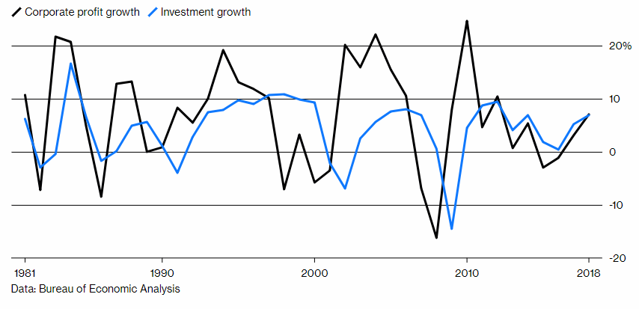

**Figure 1. Corporate Profit Growth & Investment Growth. Retrieved from Bloomberg, 2018.**

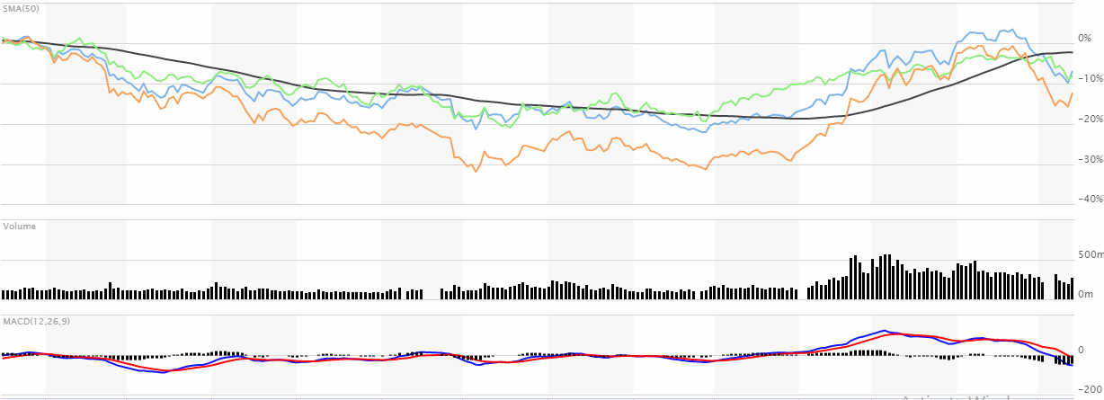

**Figure 2. Shanghai Composite, HanSheng Index and Shenzhen Composite. Retreived from MarketWatch, 2019.**